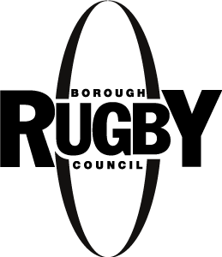
Love Rugby Festival 2025

Friday 20 June to Sunday 6 July

If you are seeking funding from the Love Rugby Festival Community or Sports Grants, please complete the Love Rugby Grant Application and return both to LoveRugby@rugby.gov.uk.

Proposed date/s:

Event title:

Requested Funding Amount:  (Up to £500 available for sport activities,  Up to £250 available for music, creative and community activities) | Sports (Please tick)  Community (Please tick)  Amount:  (Further details required on Grant Application Form, Applications will be assessed on a ‘first come, first served’ basis. Please note that only complete applications will be placed in the queue for assessment.)
Event Description:
(For the Love Rugby Brochure, please provide 150 words maximum which describes/sells the event)

Aim of the event:
(Describe what you’re looking to achieve by delivering the event, increasing awareness of your organisation / venue, promoting wellbeing, etc)

Type of event:
(Sporting, Music, Theatre, Creative, Art, Food and Drink, Heritage etc)
Times:
(Proposed start and finish times & duration of event)
Location/Venue address:
Is the event free of charge to attend or is there a cost?
(Please provide details)
Is the event bookable?
(Please provide booking information and details)
Audience:
(Who is the event suitable for e.g. families, adults, under 7’s, teenagers, all etc)
Photograph: | Please attach a high-resolution good quality image that may be used for promotional purposes. It can be a headshot, previous event image or generic image that reflects the proposed event.
Organisers Name and contact details (These will not be printed) | Name:  Email:  Phone Number:

Please complete and return this form electronically by Wednesday 30th April 2025 latest to LoveRugby@rugby.gov.uk. If you have any questions or require further information, please call Chris on 07538 917079.

