
Rugby Sports Awards 2024
nomination form

Thursday 10 April 2025
The Benn Hall, Rugby, CV21 2LN

Closing date for nominations Friday 28th February2025

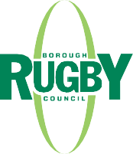

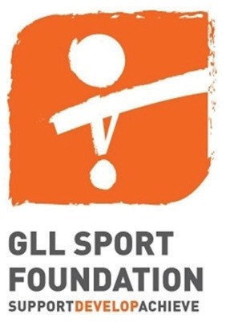

Nominations are welcome for successes and achievements between 1 January 2024 and 31 December 2024
- Please include as much detail as possible as the panel will only judge each category on this evidence
  - Additional attached information will not be judged
    - Please ensure contact details are correct
    - Juniors are classed as aged 18 or under on 31 August 2024

Mark Gallagher Memorial Award for Coach of the Year
Open to anyone who lives or coaches in a sports club
or organisation in Rugby Borough. Coaches should be nominated for their dedication, commitment and
achievements during 2024. Please tell the judges about the coach’s role and the hours this involves, qualifications, how long they have been involved with the club and what makes them so special. Also state any achievements and successes the individual team or club have had, with whom this coach is associated with.

Club of the Year Award
Open to sports clubs based in the borough. Clubs should be nominated for their success in sport and their developmental initiatives. Please tell the judges about the development of coaches, officials and volunteers and any new opportunities for new and existing members, which
have been introduced. Please include any involvement with local networks and national initiatives, developing new sections and achieving club accreditation.

The Unsung Hero ‘Volunteer’ Award
Open to anyone who lives or volunteers in a sports club or organisation based in the borough. People should be nominated for their involvement and commitment to volunteering in 2024. They should be an inspirational role model, perhaps someone who shows dedication behind the scenes, but whose contributions may otherwise go
unrecognised. Please explain how important their role is and the time this involves.

Sportsman of the Year Award
Open to anyone who lives or participates in sport in the borough. People should be nominated for their achievement or success in their sport during 2024. Please tell the judges about their background in the sport and why they deserve the award.

Sportswoman of the Year Award
Open to anyone who lives or participates in sport in Rugby Borough. People should be nominated for their achievement or success in their sport during 2024. Please tell the judges about their background in the sport and why they deserve the award.

The Lifetime Achievement Award
Open to anyone who lives or is involved with a sports club or organisation in Rugby Borough. People should be nominated for their involvement, commitment and dedication to sport over many years. Please tell judges how many years they have been involved and how their long service has made a difference to sport.

Excellence in Sport Award
Open to young people aged 18 or under on 31 August 2024 who represent a particular sport at a national or international level. This may be as part of a national
development squad, competing for their country or having achieved a national title. Nominees must be a resident
of the borough/go to school or represent a sports club or organisation in the borough and be in full-time education. 10 winners will be selected by a panel of judges and will be invited to attend the awards evening to be awarded £100 towards training or equipment expenses.

Simon Warwood Memorial Award for Young Team of the Year
Open to sports teams based in Rugby Borough (maximum
age group under 18). Teams should be nominated for their achievements and success in sport and for demonstrating excellent team spirit, commitment and a sense of fair play during 2024. Nominations are welcome from school teams as well as clubs.

Young Volunteer of the Year Award
Open to anyone aged 18 or under on 31 August 2024, who lives or volunteers in a sports club or organisation in the borough. People should be nominated for their involvement and commitment in their sport; a positive role model who inspires and engages with the community.

Young Sports Person of the Year Award
Open to young people aged 18 or under on 31 August
2024 who are a resident of the borough/or go to school or represent a sports club in the borough. Young people should be nominated for their achievement and success in their sport during 2024, but should also show involvement and commitment to their club/sport to go the extra mile.

Get Active Award
This award recognises an individual who has significantly improved their health and wellbeing by becoming more physically active, either through sport or regular exercise. This person may have overcome a number of barriers, including their physical and mental health, disability or impairment, and should have a story to tell that may inspire others to become more active

Women’s Rugby Player of the Year Award
To celebrate the Women’s Rugby World Cup, we are looking
back on our amazing athletes in the women’s game. Open to anyone who lives or participates in rugby in the Borough of Rugby. People should be nominated for their achievement or success in the sport during 2024. Please tell the judges about their background in rugby and why they deserve the award.

Rugby Sports Awards 2024 Nomination Form

Nominator
Name: ...........................................................................................................................................................................................
Address:.......................................................................................................................................................................................
.........................................................................................................................................................................................................
...................................................................................................................Postcode: ..................................................................
Telephone number: .................................................................................................................................................................
Email address: ..........................................................................................................................................................................
How do you know the nominee? .......................................................................................................................................

Nominee
Address:.......................................................................................................................................................................................
.........................................................................................................................................................................................................
...................................................................................................................Postcode: ..................................................................
Telephone number: .................................................................................................................................................................
Email address: ..........................................................................................................................................................................
Date of birth: .............................................................................................................................................................................
Sport: ............................................................................................................................................................................................
Sports Club: ...............................................................................................................................................................................
Level of involvement:.............................................................................................................................................................



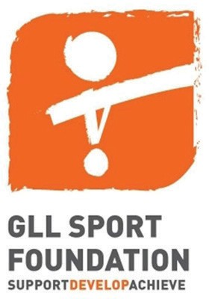
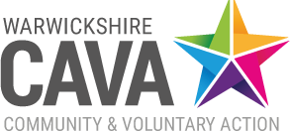

Category (please tick ONE box)

Mark Gallagher Memorial Award for Coach of the Year
 Club of the Year Award
The Unsung Hero ‘Volunteer’ Award  Sportsman of the Year Award
Sportswoman of the Year Award
The Lifetime Achievement Award

Excellence in Sport Award
Simon Warwood Memorial Award for Young Team of the Year
Young Volunteer Award
Young Sports Person of the Year Award Get Active Award
Women’s Rugby Player of the Year Award

Reasons for nomination
Please state your reasons for nominating. Please highlight achievements and successes, why the nominated person deserves the award and any other relevant information as stated in the award criteria. All nominations are for successes and achievements between 1 January 2024 and 31 December 2024.

Closing date for nominations is Friday 28th February2025
All nominations will be judged by a panel who will shortlist a number of applications. Those shortlisted will be invited to attend the awards evening where the winner of each category will be announced.

Please return completed nomination forms to: Sport and Recreation Team, Rugby Borough Council, Evreux Way, Rugby, CV21 2RR by Friday 28th February 2025
Data Protection Statement
The purpose for collecting your personal details on this form is to allow the council to process and make an assessment of your nomination for a Sports Award. Once the form has been completed the council will store the details securely and confidentially.Access to the information you provide will be on a strictly need to know basis and the information will be retained for two years before being securely disposed of/deleted from our systems. This information may be shared with Think Active to nominate at the sub-regional Think Active Awards. It will not be shared externally with any other organisations or partners.I do not wish for the information provided to be shared with Think Active to nominate at the Think Active Awards (please tick)

If this information is difficult to understand, we may be able to provide it in another format, for example in large print, in audio, or in another language. Please contact the Communications team on (01788) 533864, or email: communications@rugby.gov.uk

